**11 - ServiceNow Transform and Field Maps**

Transform maps help move data from the import set table to the target table. This process involves field mapping and data transformation. Administrators use the Transform Maps module to set the destination for imported data on any table. Transform mapping can be done easily by dragging and dropping to link source fields from the import set table to destination fields on any table. Use transform mapping to dynamically map source and destination fields.

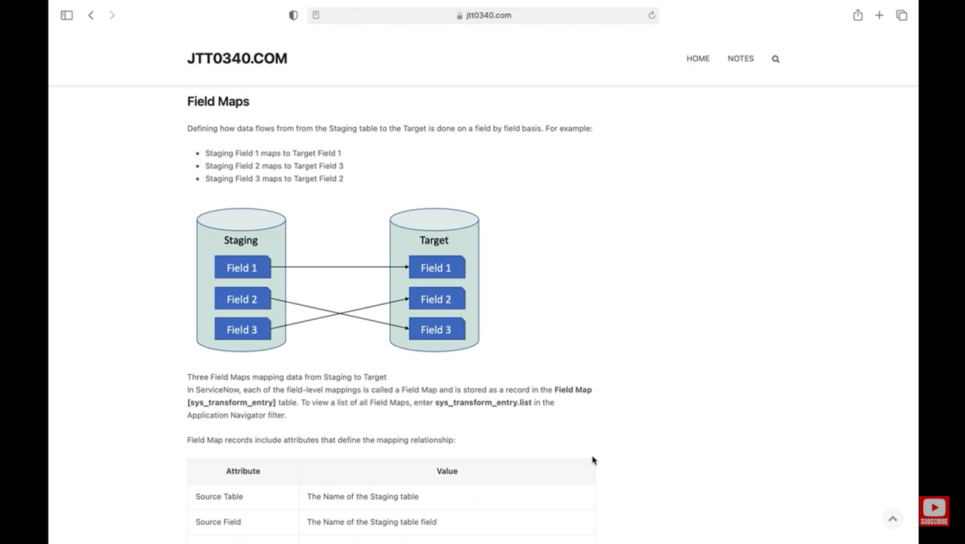

**Transform Considerations :  
Auto mapping -** Ensure that the fields automatically mapped by the system are necessary. For instance, encrypted passwords likely should not be mapped.

**Mapping Reference Fields** - When mapping reference fields, if the sys_id doesn't exist, it could appear as the DisplayValue in the target record, which might be undesirable. Mapping many reference fields can slow performance because the system checks if the referenced sys_id exists before performing actions at the field level.

**Using Multiple Transform Maps -** You can apply multiple transform maps to a single data source. Each transform map creates an import set row, which can generate many temporary records. Users can select multiple transform maps during data import, and they will be executed on the same import set in the specified order.

**Transformation Events -** It happen during the process of converting data from an import set table to a target table. These events alter the transformation behavior based on the mapping specifications. Event scripts can change how these events are processed at various stages of transformation. For example, scripts can adjust the mapping operations defined using the Mapping Assist Utility. Several JavaScript objects representing tables or parts of tables can be accessed during these events, with their references varying by event context.

Key transformation events include:

onStart  
onComplete  
onBefore  
onAfter  
onForeignInsert  
onChoiceCreate  
onReject

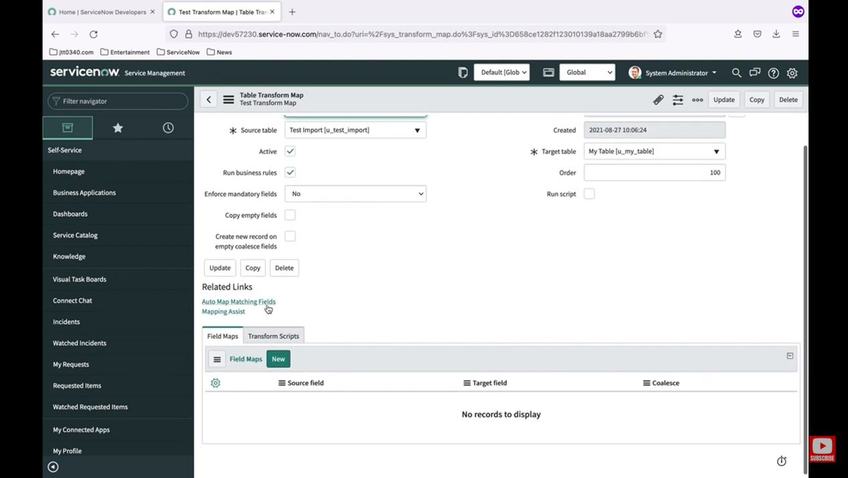

ANANYA CHOUDHARY